**Evaluating Management Strategies for Atlantic Bluefin Tuna**

***Report 5: completion and release of the first comprehensive ABFT MSE package for use in MP testing by stakeholders.***

January 29th 2018

SHORT-TERM CONTRACT FOR MODELLING APPROACHES: SUPPORT TO BFT

ASSESSMENT (GBYP 06/2017) OF THE ATLANTIC-WIDE RESEARCH PROGRAMME ON

BLUEFIN TUNA (ICCAT-GBYP – Phase 7)

Tom Carruthers[1]

UBC

**Executive Summary**

The focus of this contract was the production of a fully documented working MSE framework including all finalized operating models (both reference and robustness) to allow stakeholders to develop and test their own Management Procedures. In this regard, a number of major milestones were achieved in this contract:

Operational modelling

- To accommodate the requirements of the reference and robustness operating models, the M3 model was updated from 1.3 through to 1.7.

- All reference operating models were fitted to data and presented to the core modelling group including a summary SCRS paper that has been submitted to the Redbooks ([Carruthers and Butterworth 2017a](https://drive.google.com/open?id=1uhkNrHlip7CTVn4CFMk4lJP22mi-y7RS)).

- All robustness operating models were fitted to data and are to be summarized in a 2018 SCRS paper.

- The 36 reference and 4 robustness operating models (for which a standard OM fitting report is available for each) were included in the [ABT-MSE R package](https://drive.google.com/open?id=1eJQ_DcZcceYBBJAVNzqkLFxf4VProdZo) for use in MP testing.

MSE development

- Following the performance metrics of the updated trial specifications document the R package includes a performance table function getperf() and an MSE performance metrics plot PPlot() to standardize outputs from the MSE runs of users (see Section 7.4.5 of the

- Standardized operating model fitting reports ([an example](https://drive.google.com/open?id=1ppVm2mTsWjZsqtrl-RFQILsmO_OPNpJ0)) were updated following feedback from the Core Modelling Group including a new, additional OM comparison report ([see example for the reference operating models](https://drive.google.com/open?id=1HCzvlkzVStkHZL-As7AOQgYHuQl3-2-C)).

- All of the latest R code, data and objects were compiled into a single R package ([ABTMSE](https://drive.google.com/open?id=1eJQ_DcZcceYBBJAVNzqkLFxf4VProdZo)) with complete documentation for all functions, objects and data to be used in MSE analyses.

- The raw data, R scripts, Reports, help documentation and the R package were assembled in a single directory which can be downloaded from either the [ICCAT GitHub repository](https://github.com/ICCAT/abft-mse) or a [Google drive](https://drive.google.com/open?id=0B0TXcs-MLRl3c0w4VF9QbkJYOU0).

Documentation

* An SCRS paper was submitted to Redbooks demonstrating the design and implementation of new MPs in the R package: [Carruthers and Butterworth 2017 b](https://drive.google.com/open?id=1gauaI74rowuzY3pAE-qFFlWQuY9wElPI) (Appendix 1)
* An SCRS paper was submitted to Redbooks introducing the ABT-MSE R package and its capabilities [Carruthers and Butterworth 2017c](https://drive.google.com/open?id=1IBcZhxNJXwSKkmEoAFoGrj7BhzilNt81) (Appendix 1)
* A draft peer-review paper has been produced describing and testing the first ever multi-stock, multi-index management procedure designed specifically for Atlantic bluefin tuna (Carruthers et al. 2018) (Appendix 2)
* The [Trial Specifications](https://drive.google.com/open?id=14j33JBhoep0TtvRj4pBkA8cIwM7XhGz3) was updated to include new OM definitions and performance metrics (Appendix 3)
* User guides for [M3 (v1.7)](https://drive.google.com/open?id=1GwBgtHzPsk4uZVO5wPri8jiPVc-YgPlF) and [ABT-MSE R package (v2.3)](https://drive.google.com/open?id=1tlNj3NZ1VXNwWq46dVKbqUTQgUI8Fp70) have been updated with new tutorials and examples of MP development. The user guide was developed in R markdown that describes the file structure, the project and guides users through the various functions of the R package including worked examples of the 7 steps of MSE development (of Punt and Donovan, 2007)(Appendix 4).

- [Software design documentation](https://drive.google.com/open?id=1OcadeChBHx3SFouqayIBg6NuzgMSkwSR) was updated for the latest version of the ABT-MSE R package(v2.3.0).

Contents

1 Review of contract activities 2016 - 2017 4

1.1 Data preparatory meeting (July 24th – 29th) 4

1.2 Species group meetings (September 26th – 30th) 4

1.3 Meeting of the Core Modelling Group (November 5thth – 6th) 5

1.4 Developments since November 2016 5

2 Progress with respect to deliverables 6

3 Current status of objectives 7

4 Priorities for the MSE process 8

4.1 Finalising operating models (approving fit and predictions) 8

4.2 Stakeholder specification of OMs and MPs 9

5 MSE development priorities 9

5.1 Review of code and MSE bug checking 9

5.2 Incorporating the test unit into the R package (major) 9

5.3 Development of inverse age-length keys (major) 9

5.4 Implement the max / min TAC changes of the Trial specifications document (minor) 9

5.5 More extensive MSE diagnostics and reporting (major) 9

5.6 Data-rich MPs (major) 10

5.7 Updating of the shiny app and the Bayesian Belief Network (major) 10

5.8 Update the OM fitting report (minor) 10

5.9 Better characterization of observation processes, for example what is an appropriate / credible degree of bias in age at maturity BMSY/B0, FMSY/M etc (major) 10

6 Appendices 11

6.1 Appendix 1: Master Index 11

6.2 Appendix 2: Trial Specifications 11

6.3 Appendix 3: ABTMSE R package 11

6.4 Appendix 4: R package user guide 12

6.5 Appendix 5: Web site 12

6.6 Appendix 6: SCRS papers 12

# Review of contract activities 2017 - 2018

## Data preparatory meeting (July 24th – 29th)

Two papers were presented at the data preparatory meeting demonstrating the successful simulation testing of the M3 multi-stock operating model ([SCRS/2016/144](https://drive.google.com/open?id=0B0HYOP0BN5RPY3N2a3ZfaEoxVk0)) and another highlighting the outstanding issues pertinent to the conditioning of operating models on real data ([SCRS/2016/145](https://drive.google.com/open?id=0B0HYOP0BN5RPTE1IMUM0OE9wZ1E)).

Following the data-preparatory meeting (July 24-29) all data for fitting operating models were made available to the core modelling group (CMG). This allowed for an update in the meta-data summary, the preliminary fitting of operating models to real data and a revision of the Trial Specifications document, for example the definition of fleets and the start / end dates for the data to be used in the operational modelling.

Together, the update in the Trial Specifications document and the provision of data allowed for the fitting of preliminary operating models (large grey shaded box ‘Operating model specifications’ of Figure 1). Code was developed to link these outputs to the ABTMSE R package (the linkages through MLE, Hessian and MCMC sample boxes of Figure 1 below).

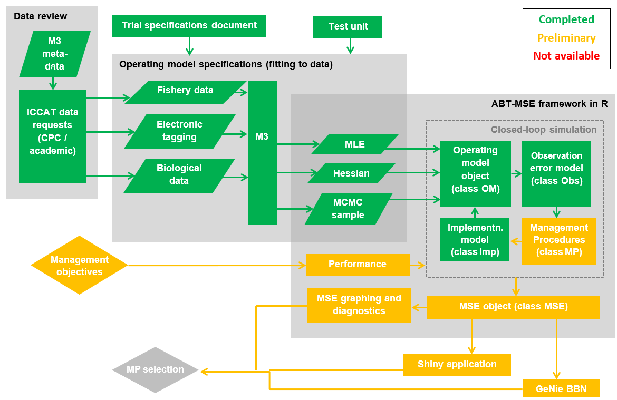

Figure 1. Current status of the components of the ABT MSE framework.

## Species group meetings (September 26th – 30th)

A pair of papers were presented describing the opportunities for operational modelling ([SCRS/2016/204](https://drive.google.com/open?id=0B0HYOP0BN5RPbU5EV0RiRjZzUG8)) and a new approach for imputing stock of origin to electronic tags using their spatial fingerprint ([SCRS/2016/205](https://drive.google.com/open?id=0B0HYOP0BN5RPUmxaMHE2MnZOajQ)). Following feedback from members of the CMG the R ABTMSE framework was updated as was the [meta-data base](https://docs.google.com/spreadsheets/d/%2013pFaM3BTnzQ1BNQGoYn4O2n1IeD18V3VTbN9Hv7139U/edit) which is now linked to the real data on the ICCAT [GitHub page](https://github.com/ICCAT/abft-mse).

## **Meeting of the Core Modelling Group (November 5thth – 6th)**

The 18 reference operating models were fitted to data and a [standardized report](https://drive.google.com/open?id=0B0HYOP0BN5RPYXNWVHdxSjNTa2s) was designed using R markdown, which allows any user to rapidly produce model diagnostics and estimates of management reference points. These fitted operating models were presented to the CMG following the Tuna MSE working group meeting.

Feedback from the CMG focused on finalizing the Trial Specifications document and reconfiguring the operating models. A substantial change in M3 operating model structure was proposed relating to model initialization. Rather than assuming a stable rate of fishing mortality rate prior to 1960 the model is now initialized by stock reduction analysis (SRA, the deterministic subtraction of catches) accounting for removals from 1860 to 1959. The operating model would also now be fitted to CPUE indices that are used in the stock assessments.

## Developments since November 2016

As requested by the CMG, an SCRS paper was drafted describing in greater detail the derivation of the ‘master index’ that is used to condition the operating models ([Appendix 1](https://drive.google.com/open?id=0B0HYOP0BN5RPN3VxTmo4SVZqQUE)). The paper discusses the advantages and disadvantages of the approach and highlights future priorities for research.

Since the CMG meeting at the start of November, the Trial Specifications document (latest version is attached in [Appendix 2](https://drive.google.com/open?id=0B0HYOP0BN5RPSzJMS0RRUW9sUUU)), operating model and R ABTMSE framework were reconfigured to incorporate this change in model structure. The [OM fitting report](https://drive.google.com/open?id=0B0HYOP0BN5RPYXNWVHdxSjNTa2s) was also refined to include better diagnostics of fit to length composition data.

A series of improvements to the R MSE framework were implemented. These include custom classes for operating model inputs, performance metrics, observation models and management procedures. The observation model was updated to generate future indices based on the statistical properties of model fit to prospective indices (e.g. the real Mediterranean larval survey). A range of new management procedures were added that make use of these indices including new surplus production, delay-difference and catch-based MPs (there are now 23 example MPs).

The R MSE framework was consolidated into a single R package (ABTMSE) in which all functions and objects are documented including worked examples ([Appendix 3](https://drive.google.com/open?id=0B0HYOP0BN5RPeDJYVE5mT0FGSTg)). MSE diagnostics were produced that match those of the Trial Specifications document including performance metrics, performance summary tables and projection plots.

A user guide was produced in R markdown ([Appendix 4](https://drive.google.com/open?id=0B0HYOP0BN5RPV1BXOGk0cEwyTGM)) that describes and demonstrates the package functionality including the ‘7 steps of MSE’ as described by Punt and Donovan (2007):

(1) qualitative specification and prioritization of the management objectives, as derived from legislation, legal decisions, and international standards and agreements;

(2) quantification of the qualitative management objectives in the form of performance measures;

(3) development and parameterization of a set of “operating models” that represent different plausible alternatives to the dynamics of the “true” resource and fishery being managed;

(4) identification of candidate management procedures, including monitoring strategies;

(5) simulation of the future use of each candidate management procedure, involving for each time-step during the projection period: (a) generation of assessment data; (b) determination of the management action (i.e. assessment and application of some HCR); and (c) evaluation of the biological implications of the management action by removing the catch from the population as represented in the operating model;

(6) summary of the performance of the candidate MPs in terms of values for the performance measures; and

(7) selection of the management procedure that best meets the specified objectives.

Using a pre-release R package [pkgdown](https://github.com/hadley/pkgdown) a website was produced for the ABTMSE package. This allows for automated online documentation each time the package is updated. It can also serve as a splash page for the ICCAT/abft-mse repository ([Appendix 5](https://drive.google.com/open?id=0B0HYOP0BN5RPS0l6Q2cwb1FpVU0) – to view the website download /docs folder and open docs/index.html ).

Software design documents were updated for the ICCAT ABTMSE R framework and M3 assessment model.

# Progress with respect to deliverables

|  |  |  |
| --- | --- | --- |
| **Deliverable 1 July 20, 2016 (100%)** | | |
|  | i | Workplan outlining the actions required to complete the 5 components of deliverable 3 |
|  | ii | Presentation and short report summarizing current status of deliverables and actions required to achieve them |
|  |  |  |

(i) The workplan was presented in Progress Report 5 (Section 5)

(ii) This deliverable was addressed in Progress Report 4 and accompanying presentations.

|  |  |  |
| --- | --- | --- |
| **Deliverable 2 September 23, 2016 (100%)** | | |
|  | i | Updated presentations and short report summarizing current status of deliverables and actions required to achieve them (100%) |
|  | ii | Demonstrator showing the MSE running, should include examples of the 6 steps of developing an MSE (100%) |
|  | iii | Draft papers on applications (100%) |
|  |  |  |

(i) The purpose of Progress Report 5 and accompanying presentations was to summarize current status.

(ii) The R package and user guide not only demonstrate the MSE working, but provide users with an opportunity to design their own operating models, performance metrics and management procedures.

On a more conceptual level, the [**shiny app**](http://rscloud.iccat.int:3838/gbyp-mse/)also provides users with a rapid investigation of MSE design and outputs.

(iii) A review paper discussing the potential future applications of bluefin tuna operating models was presented at the September 2016 species group meeting (SCRS/2016/204).

|  |  |  |
| --- | --- | --- |
| **Deliverable 3 Draft: February 13, 2017 Final: February 21, 2017 (100%)** | | |
|  | i | Repository with version control for software development <http://github.com/ICCAT/abt-mse> containing the OM (~100%) |
|  | ii | SDP (Software Development Plan) that will be reviewed by external experts, as agreed at Monterey meeting (~100%) |
|  | iii | Test Unit so that code can be validated (100%) |
|  | iv | Meta Database summarizing all parameters and assumptions used <http://github.com/ICCAT/GBYP-MetaDB> (100%) |
|  | v | Management Procedures Support the implementation of 3rd parties. Written up as SCRS paper and code available in repository (100%) |
|  |  |  |

(i) Following the completion of version 1.0 of the M3 operating model, the ICCAT MSE GitHub site is now subject to regular updates following developments to code and software documentation (current version is 1.3). Branching, merging, pulls, commits etc. may be managed either by me the Technical Assistant or ICCAT staff.

The new automatically generated website can be used as the splash page for the GitHub site (linking the master branch to ICCAT/abft-mse/docs) and offers a user-friendly front-end with access to supporting documentation.

(ii) The software development plan is currently being revised in light of the recently launched R package. This revision is necessary because R packaging offers many new opportunities and several constraints.

Updated software design documents and manuals (abft-mse/Manuals_and_design_documents/) are available for the latest version of the M3 operating model ([v1.3](https://drive.google.com/open?id=0B0HYOP0BN5RPYkJ4X0QydjZUNGM)).

(iii) A test unit has been developed that matches the new features of the latest M3 model (v1.3). The simulator is built into the R ABTMSE package and uses streamlined operating model objects (OM definition objects) to generate simulations and calculate reference points.

(iv) The meta-database is available as a publically editable [google worksheet](https://docs.google.com/spreadsheets/d/%2013pFaM3BTnzQ1BNQGoYn4O2n1IeD18V3VTbN9Hv7139U/edit#gid=1352276725). Several scientists have contributed to refining the metadata.

In instances where data are used by the operating models, the google sheet now contains hyperlinks to the real data that are stored on the [ICCAT GitHub repository](https://github.com/ICCAT/abft-mse/tree/master/Data).

# Current status of objectives

|  |  |  |
| --- | --- | --- |
| **Objective** | | **Tasks (bold are completed)** |
| **a**  (100%) | Continue the development of the OM based on the MSE trial specifications document (TS) | **Added (M3 v1.3):**  **age-based movement, plus group, model initialization at equilibrium estimated F, recruitment predicted from SSB in previous year, a prior for depletion to allow the model to fit specified depletion.** |
| **b**  (100%) | Develop a test unit to validate the age-based movement model | **Test unit updated to match developments in the operating model above (a)** |
| **c**  (0%) | Work with third parties to add MPs to the MSE framework including empirical control rules and simple stock assessment methods | Reach out to national scientists, members of the BFT WG (possibly leverage the chairs of Eastern and Western WGs) and the CMG to develop new MPs or to incorporate existing MPs (e.g. CCSBT).  It may be appropriate to attempt this objective during the MSE demonstration workshop aimed at achieving (d) below. |
| **d**  (0%) | Run the MSE in collaboration with BFT Species group | This objective requires a dedicated workshop in 2017.  A precursor to such a workshop is finalization of the reference operating models (approving acceptable fit to data), fitting the robustness set of operating models and the integration of these into the R ABT-MSE framework. |
| **e**  (100%) | Collaborate with the SCRS to develop interactive graphics (e.g. Shiny apps) to communicate MSE results to stakeholders based on the performance metrics of the trial specifications document | **A preliminary Shiny App is now available at:** [**http://rscloud.iccat.int:3838/gbyp-mse/**](http://rscloud.iccat.int:3838/gbyp-mse/)  The App should be modified following finalization of the reference and robustness operating models.  The App should include sufficient flexibility to allow users to define their own OMs and investigate value of information. |
| **f**  (100%) | Work with other to update and maintain the meta database of the available bluefin data and knowledge https://github.com/ICCAT/GBYP-MetaDB | **The meta database has been made publically available and editable** <https://drive.google.com/open?id=13pFaM3BTnzQ1BNQGoYn4O2n1IeD18V3VTbN9Hv7139U>  The google sheet has been updated by myself and H. Arrizabalaga to reflect the latest status of BFT data. |
| **g**  (100%) | Work with SCRS to help develop 3 prototype examples | The user guide has several worked examples of MP development .  The ABTMSE R package also includes 23 examples of MPs each of which has accompanying documentation. |

The underlying objective of this contract was to provide an accessible, flexible and powerful MSE framework to allow scientists and stakeholder the opportunity to test new management procedures, design new operating models and investigate performance metrics. To achieve this objective, a number of deliberate design choices were made:

* The formulation of a single file structure containing all data, code and documentation maximises the portability and accessibility of the ABT MSE framework.
* By developing an R package all of the code, functions, MSE objects and worked examples are available in a single file that may be easily distributed. Since all data and functions have documentation there is local support for developers that wish to design their own management procedures, operating models or performance metrics.
* By packaging the MSE framework in R, the code is accessible to a wide range of scientists and they can easily use the powerful and varied additional packages and functions of the R statistical environment.
* By producing documentation in R markdown, tutorials are reproducible and transparent allowing new users to be guided step-by-step through the various steps of MSE analysis.
* One-click web page production means that with every package revision, the supporting documentation can be easily updated online.
* By staging the software in GitHub, users can track changes to the package, get news on updates, submit ‘issues’ to the developer when errors are found and branch the code to make customised changes.

Two objectives were not yet met, namely

(c) 3rd party MP development and

(d) running of MSEs in collaboration with the BFT species group.

However due to progress in this contract, the MSE framework is in excellent shape to deliver these objectives in the near future.

# Priorities for the MSE process

## Finalising operating models (approving fit and predictions)

During the CMG meeting in November 2016, feedback was provided on the fit of the existing operating models to data and the apparent divergence in model predictions from recent stock assessments. A core recommendation arising from this meeting was that the operating model (the M3 estimation model) should be restructured to account for historical catches prior to 1960 and that it should be fitted to stock assessment CPUE indices of abundance.

Since that meeting there has not been an opportunity for the CMG to examine and approve the latest operating model fits to data. Indeed these models appear to fit the assessment data but also disagree to a certain extent with recent assessments (albeit less so than the previous model formulation). Because it is the remit of the CMG to approve the operating models, my time has been spent producing a workable MSE framework that can integrate any fitted operating model. Once final decisions on acceptable operating model fits have been obtained (e.g. a decision to up-weight the fit to assessment indices) it is straightforward and quick to re-fit the models and incorporate these into the MSE R framework.

This remains a leading priority.

## Stakeholder specification of OMs and MPs

This contract has focused on producing an accessible framework for engaging stakeholders in the MSE process. A leading priority going forward is to schedule seminars and workshops to facilitate the engagement and collaboration of stakeholders.

# MSE development priorities

## Review of code and MSE bug checking

It is possible to develop an MSE framework that appears sound but provides spurious results due to coding errors or model misspecification. It is important to both review the code line-by-line (the package is new and has not yet been carried out) and also produce a series of diagnostic checks that can be run each time the package is formulated. For example, a simple check would be to produce several management procedures all with increasing levels of constant catches and confirm the expected increasing impact on predicted stock biomass. Similarly, another test could be to change the configuration of fleets toward those that catch smaller fish and check for the corresponding shift in simulated catch composition.

## Incorporating the test unit into the R package (major)

Currently the test unit (which validates the operating model by simulation testing) is not integrated into the ABTMSE R package. This is a valuable addition that adds credibility to the operational modelling.

## Development of inverse age-length keys (major)

Currently the inverse age-length keys (probability of a fish being of length class given age class) were derived by myself using a very naïve approach. A 10% coefficient of variation was superimposed around the maximum likelihood fit of the Richards growth curve following (Allioud et al.). More defensible inverse age-length keys are desirable that have documentation about how they were derived. For example, time-varying inverse age-length keys are accepted by the M3 operating model that could be derived empirically from raw age-length data.

## Implement the max / min TAC changes of the Trial specifications document (minor)

The Trial Specifications document requires that the MSE impose maximum and minimum changes in TAC among TAC updates by MPs. This is to prevent management overhead from trivial changes in TAC and prevent unrealistically large swings in TAC. This is straightforward to include in the current MSE framework.

## More extensive MSE diagnostics and reporting (major)

Currently the ABTMSE R package includes quite basic MSE analysis, reporting and diagnostics. The current reporting options are the minimum required to meet the outputs described in the Trial Specifications document. However there are some useful additional outputs that could be developed in the near-term to greatly improve the power and flexibility of the package including:

* Pencil plots showing biomass and exploitation rate projections (similar to the existing shiny app)
* Convergence diagnostics that confirm the MSE results are stable given additional simulations
* Value of information analysis demonstrating which observation processes and operating model parameters are the primary drivers of performance
* A standard MSE report document designed in markdown (similar to the operating model fitting report)

## Data-rich MPs (major)

Many of the management procedures that are currently specified operate on few data or are simple stock assessments that do not account for process error. It would be desirable to develop MPs that represent current stock assessment for Atlantic bluefin stocks (a VPA) or those that can account for process error (e.g. a state-space delay-difference assessment).

## Updating of the shiny app and the Bayesian Belief Network (major)

The current shiny app provides an early example of the type of outputs that can be produced to illicit feedback from a wider group of scientists and stakeholders that are less likely to participate in coding their own operating models and management procedures. Once the operating models are finalized (e.g. their fit is considered acceptable by the CMG) the shiny app should be updated to reflect the configuration and results of the latest MSE analyses.

Although there appears to be a preference for presentation of MSE analyses by the shiny app, it is straightforward to update the Genie Bayesian Belief Network. The BBN has additional value because it allows users to define and investigate custom utility functions which is much less straightforward in a Shiny app.

## Update the OM fitting report (minor)

The operating model fitting report should be revised following feedback on the desired representation of fits to indices (comment from D. Butterworth) and the order of presentation.

## Better characterization of observation processes, for example what is an appropriate / credible degree of bias in age at maturity BMSY/B0, FMSY/M etc (major)

Currently the MSE generates simulated data subject to naïve observation error models, particularly annual catch data, catch-at-length and catch-at-age data. The models should be revised to include more complex processes that are representative of data-collection protocols for Atlantic bluefin tuna.

**Acknowledgments**

Many thanks to my coauthors of the various SCRS papers. Thanks in particular to Laurie Kell for technical support, Antonio di Natale for directing the project and Doug Butterworth for advancing the Trial Specifications document.

This work was carried out under the provision of the ICCAT Atlantic-Wide Research Programme for Bluefin Tuna (GBYP), funded by the European Union, by several ICCAT CPCs, the ICCAT Secretariat and by other entities (see: http ://www.iccat.int/GBYP/en/Budget.htm). The content of this report does not necessarily reflect the point of view of ICCAT or of the other funders, which have no responsibility for it, neither does it necessarily reflect the views of the funders and in no way anticipates the Commission's future policy in this area.

# References

Carruthers, T.R., Butterworth, D.S. 2017a. Summary of a reference set of conditioned operating models for Atlantic bluefin tuna. Col. Vol. Sci. Pap. ICCAT. 2017/223.

Carruthers, T.R., Butterworth, D.S. 2017b. Performance of example management procedures for Atlantic bluefin tuna. Col. Vol. Sci. Pap. ICCAT. 2017/224.

Carruthers, T.R., Butterworth, D.S. 2017c. ABT-MSE: an R package for Atlantic bluefin tuna management strategy evaluation. Col. Vol. Sci. Pap. 2017/225.

# Appendices

All appendix material is available on the [ICCAT/abft-mse repository](https://github.com/abft-mse/) and is contained in a single file structure that can also be downloaded [here](https://drive.google.com/open?id=0B0HYOP0BN5RPei1QSWk4WEFkSHc).

## Appendix 1: Master Index

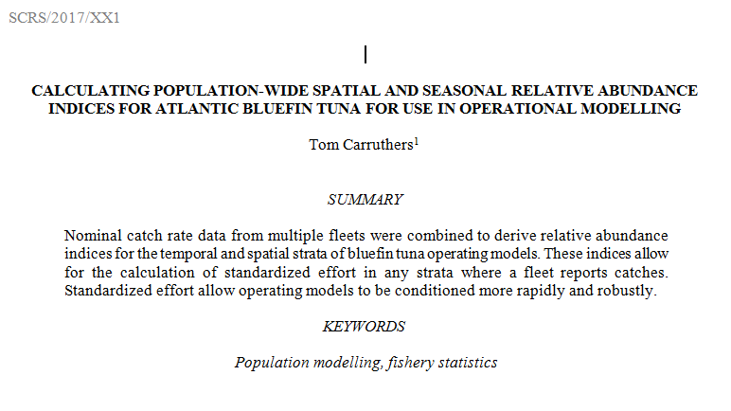

The draft SCRS paper describing the derivation of the master index:

[https://github.com/abft-mse/Submissions/SCRS_2017_XX1 Carruthers Master Indices Atlantic Bluefin.docx](https://github.com/abft-mse/Submissions/SCRS_2017_XX1%20Carruthers%20Master%20Indices%20Atlantic%20Bluefin.docx)

Also available [here](https://drive.google.com/open?id=0B0HYOP0BN5RPYjU1YnFhWFk2Ykk).

## Appendix 2: Trial Specifications

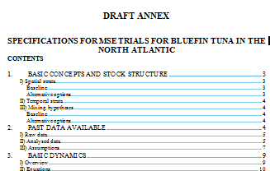

The latest version of the MSE Trial Specifications document:

[https://github.com/abft-mse/Manuals_and_design_documents/Trial Specifications.docx](https://github.com/abft-mse/Manuals_and_design_documents/Trial%20Specifications.docx)

Also available [here](https://drive.google.com/open?id=0B0HYOP0BN5RPSzJMS0RRUW9sUUU).

## Appendix 3: ABTMSE R package

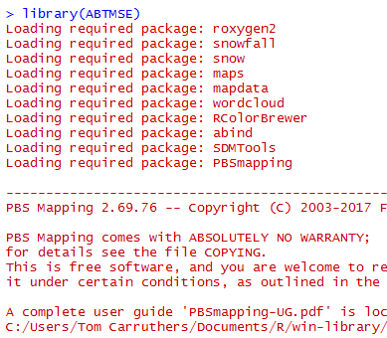

The ABTMSE R package contains all data, objects and function for users to replicate the MSE work so far and design and test their own management procedures. The R package source files are available at:

<https://github.com/abft-mse/R_package/ABTMSE/>

The package tar ball (for installation in R) is also available:

<https://github.com/abft-mse/R_package/ABTMSE_2.1.0.tar.gz>

Alternatively both are accessible [here](https://drive.google.com/open?id=0B0HYOP0BN5RPeDJYVE5mT0FGSTg).

## Appendix 4: R package user guide

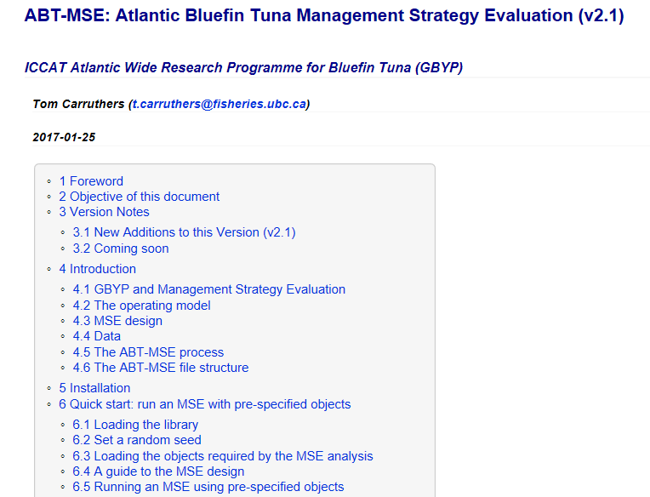

The user guide explains the design of the ABT MSE and provides worked examples of the R package functions. The user guide demonstrates the 7 steps of MSE covering custom management procedures, performance metrics and operating models. The user guide is accessible from the R package (the package vignette) or the ICCAT GitHub site

<https://github.com/abft-mse/ReadMe.html>

A copy is also available [here](https://drive.google.com/open?id=0B0HYOP0BN5RPV1BXOGk0cEwyTGM).

## Appendix 5: Web site

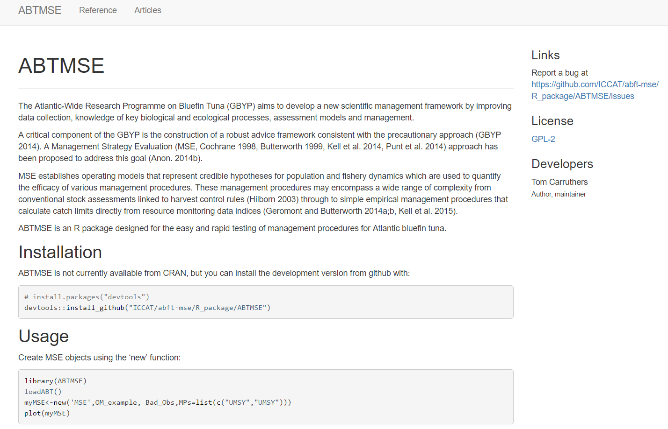

The website acts as a splash page for the ICCAT/abft-mse GitHub repository and provides background and links to help documentation and worked examples.

This can be accessed from the ICCAT GitHub site

<https://github.com/abft-mse/docs/index.html>

The website can also be accessed from [here](https://drive.google.com/open?id=0B0HYOP0BN5RPS0l6Q2cwb1FpVU0). To preview the site, you must download the /docs folder to your computer and open /docs/index.html in a web browser.

## Appendix 6: SCRS papers

The SCRS papers for this contract period (SCRS/2016/144; 145; 204; 205) are available in the GitHub repository:

<https://github.com/abft-mse/Submissions>

These are also available [here](https://drive.google.com/open?id=0B0HYOP0BN5RPX1Y2RndfbmhzOWc).

## Appendix 7: Software design documents

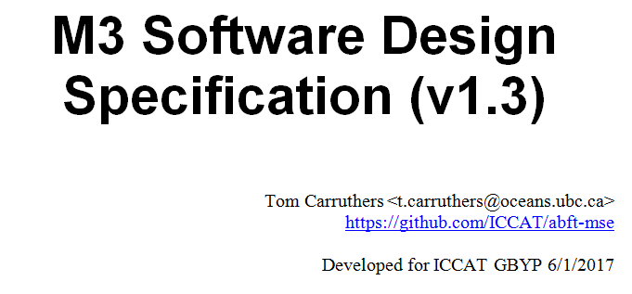The software design document for the latest M3 model is available on the ICCAT GitHub repository: [https://github.com/abft-mse/Manuals_and_design_documents/M3 Software Design Specification v1_3.docx](https://github.com/abft-mse/Manuals_and_design_documents/M3%20Software%20Design%20Specification%20v1_3.docx)

It is also available [here](https://drive.google.com/open?id=0B0HYOP0BN5RPX3dqb0ZUR2lZYWs)

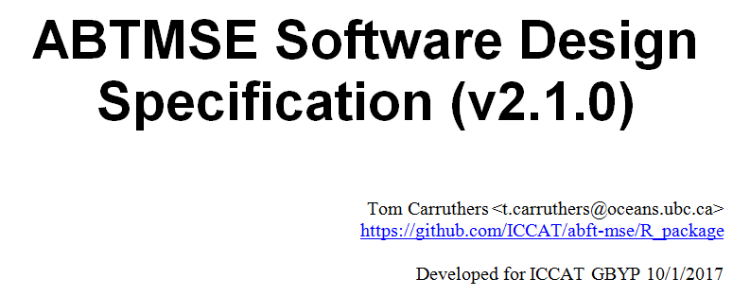

The software design specification for the ABTMSE R package is available on the ICCAT GitHub repository: [https://github.com/abft-mse/Manuals_and_design_documents/ABTMSE (R package) Software Design Specification v2_1_0.docx](https://github.com/abft-mse/Manuals_and_design_documents/ABTMSE%20(R%20package)%20Software%20Design%20Specification%20v2_1_0.docx)

It is also available [here](https://drive.google.com/open?id=0B0HYOP0BN5RPZ1BucFFQN1RlUWs).

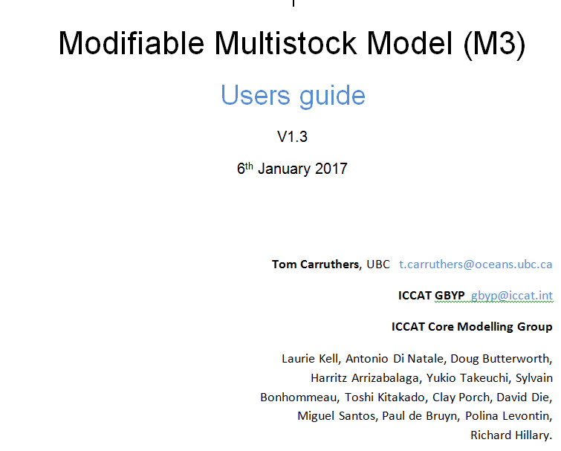

The M3 user guide is also published on the ICCAT GitHub repository: [https://github.com/abft-mse/Manuals_and_design_documents/M3 Users guide v1_3.docx](https://github.com/abft-mse/Manuals_and_design_documents/M3%20Users%20guide%20v1_3.docx)

It is also available [here](https://drive.google.com/open?id=0B0HYOP0BN5RPYjJVSmVUNktPbVE).

1. [bluemattersci@gmail.com](mailto:bluemattersci@gmail.com) 2150 Bridgman Ave, North Vancouver, Canada. +1 604 822-6903